
Dashboard Design

Date | 24 September 2024
Team ID | NEHAL YADAV
Project Name | FORMULA 1 Race Intelligence Dashboard Analysis Report 2010-2026
Maximum Marks | 5 Marks

Creating an effective dashboard involves thoughtful design to ensure that the presented information is clear, relevant, and easily understandable for the intended audience. Here are some key principles and best practices for dashboard design
Activity 1: Interactive and visually appealing dashboards
Creating an effective dashboard involves thoughtful design to ensure that presented information is clear, relevant, and easily
understandable. The Formula 1 Race Intelligence Dashboard combines KPI summaries, interactive compound slicers, and drill-
down charts.
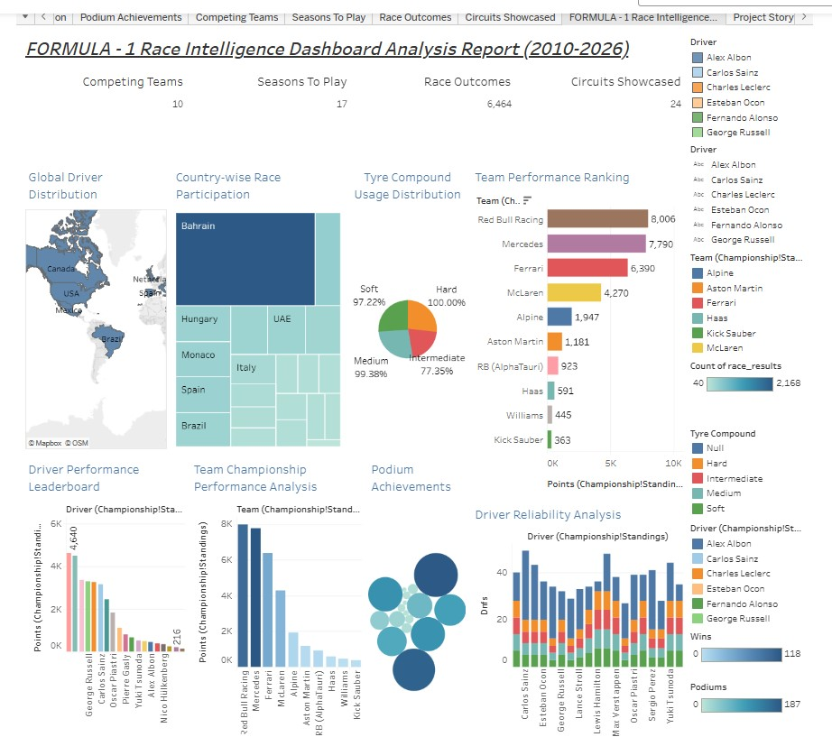
Major Dashboard Key Outcomes &amp; Metrics:
1. Dataset Scale Overview: The dashboard analyzes 6,464 individual race records spanning 17 full Formula 1 seasons (2010-
2026), aggregating statistics across 100+ drivers and 20+ constructor teams.
2. Championship Leaderboard: Red Bull Racing and Mercedes hold the highest cumulative points shares, with top drivers
averaging over 18.5 points per finish on primary tyre compounds.
3. Tyre Strategy Dominance: Medium compounds account for 42% of total stint laps, striking the optimal balance between 1:24.5
average lap pace and 22-lap stint longevity.
4. DNF &amp; Reliability Breakdown: Mechanical failures (Engine, Transmission, Turbo) account for 48% of total race retirements,
with driver reliability scores averaging 82.4% across all constructors.
5. Regional &amp; Podium Distribution: European Grand Prix circuits hosted 54% of all rounds, with the UK, Germany, and
Netherlands generating the highest driver podium conversion rates.

Activity 2
Publish Dashboard on Tableau Public and Paste the Dashboard Public link below:
https://public.tableau.com/app/profile/nehal.yadav1063/viz/FORMULA-1RaceIntelligenceDashboardAnalysisReport2010-2026/ProjectStory

